CHSC 2205 LAB NO. 6
METALLOGRAPHY

Prepared by
Nathaniel Binner-A01159743
Taylor Lee- A00899228
David Dreyer– A01035423
Set C
Team 2 Subset 1
BCIT Mechanical Engineering Technology

Prepared for
Hamed Sharif
CHSC 2205
Materials 2
BCIT Mechanical Engineering Technology

Submitted on
January 29, 2020

ENGINEERING MATERIALS

LAB NO. 6
METALLOGRAPHY
Objective:
The purpose of this experiment was to examine and understand the microstructure of two specimens: a steel nut and bolt, and a wrought iron bar. This lab required using proper metallography techniques which was not only for optimal results but as well as good practice. These techniques involved grinding, polishing, etching and microscopic examination.
Theory / Background:
The microstructure of a material holds valuable information which can be used for material research, quality control, and failure analysis investigation^{3.1}. This is due to the fact that microstructures with different sized and/or shaped grains are important factors when considering properties such as strength, ductility and toughness. Because metals can be easily modified by changing their grain structures (heat treatment, cold-working), we can determine how it was processed along with its modified properties.
If the goal is to examine and understand the microstructure of a specific material, it is important that the test of a small sample is an accurate representation of the material as a whole. For this to be achieved, the process called “metallography” is required. Metallography is “the process of preparing and examining the microstructure of metals and alloys”^{3.1}. Having proper techniques for preparation ensures more accurate results, which is critical for decisions that are based off observations; such as quality control and failure analysis.
For the microstructure to be properly examined, the surface of the specimen must be clear of any artifacts. Artifacts refer to any changes to the surface that are caused by the metallographer^{3.2}. These changes can be in the form of scratches, or any effect caused by cold-working/heat treating the sample. Ensuring that the surface is smooth and clear of any disturbed layers is required for accurate results. After the specimen is properly prepared by grinding, polishing and etching, the microscope will be able to show the microstructure due to the contrast of the grain boundaries and the surface.
The microstructure of a material is important for quality control because it can help determine if the properties standards are met. For example, a business which produces structural steel will want to ensure that their product has the rated strength, ductility, and toughness in which they advertise. Examining their samples on a regular basis can help ensure that the products they release will meet their standards.
Where the process of metallography is used for quality control before a product is released, it can also be used in a case when a failure in a material has occurred. This failure analysis is done by using the same preparing process, but in order to understand why a special has failed. Observing the grain structures of a fractured object can show vital information such as the type of fracture (impact, repeated loading), as well as environmental damage.

Data and Results:
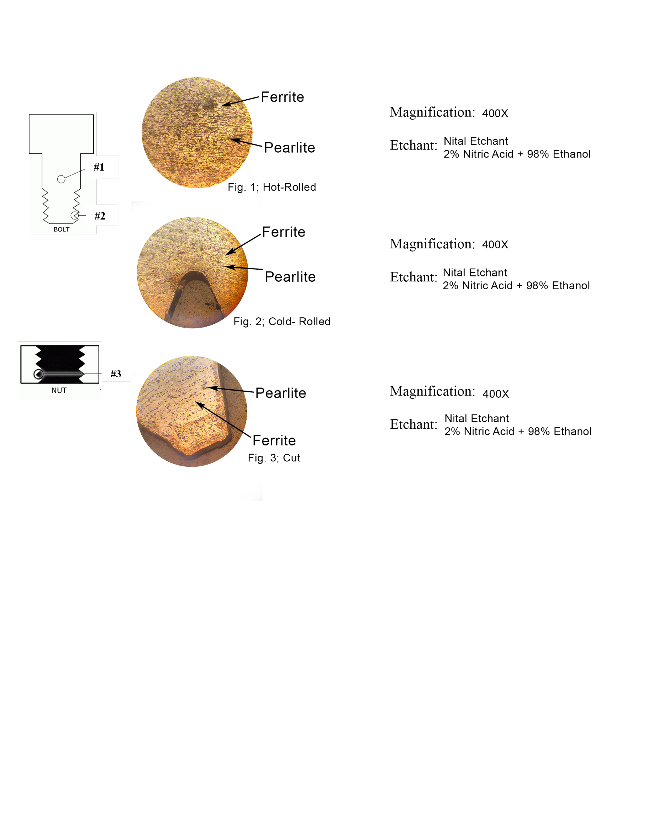
- Examination of a Steel Bolt and Nut (Label all phases on each sketch):

Discussion of a Steel Bolt and Nut:

A sample mild steel bolt was examined at 400X magnification in fig. 1 and fig. 2 and a bolt was examined at 400X in fig. 3. Each image consists of varying microstructures which suggests multiple methods were used to create the bolt. The samples were placed in a plastic cylinder and sanded down to a shiny finish to minimize surface defects.³

At the centre of the bolt (fig. 1) the microstructure is a combination of pearlite and ferrite. The pearlite grains appear elongated which suggests the sample was rolled. The ferrite grains however do not. This is due to hot rolling⁶ at a temperature above the melting point of ferrite resulting in the recrystallization of ferrite grains returning them to an equiaxed state.

In the threaded section of the bolt (fig. 2), the grains curve with the contour of the outside edge of the shape. Grains along the inner edge also appear compressed as a result of cold work. A method called “cold rolling” was likely used to create the thread in this bolt. In comparison to a cut thread, rolled thread results in more strength as a result of being subject to high pressure causing the grains to flow in many directions.⁵

In fig. 3, the steel nut is examined. As with the bolt, the grain structure appears to be ferrite with elongated pearlite in the direction of rolling. The threads of the bolt appear slightly deformed but in contrast to the threads of the bolt, the microstructure of the nut does not follow the contour of the edge. Most likely, the threads are cut. Although cutting results in slightly less strength, it allows for more accuracy and precision. A cut steel thread can later be heat-treated to improve strength if needed.

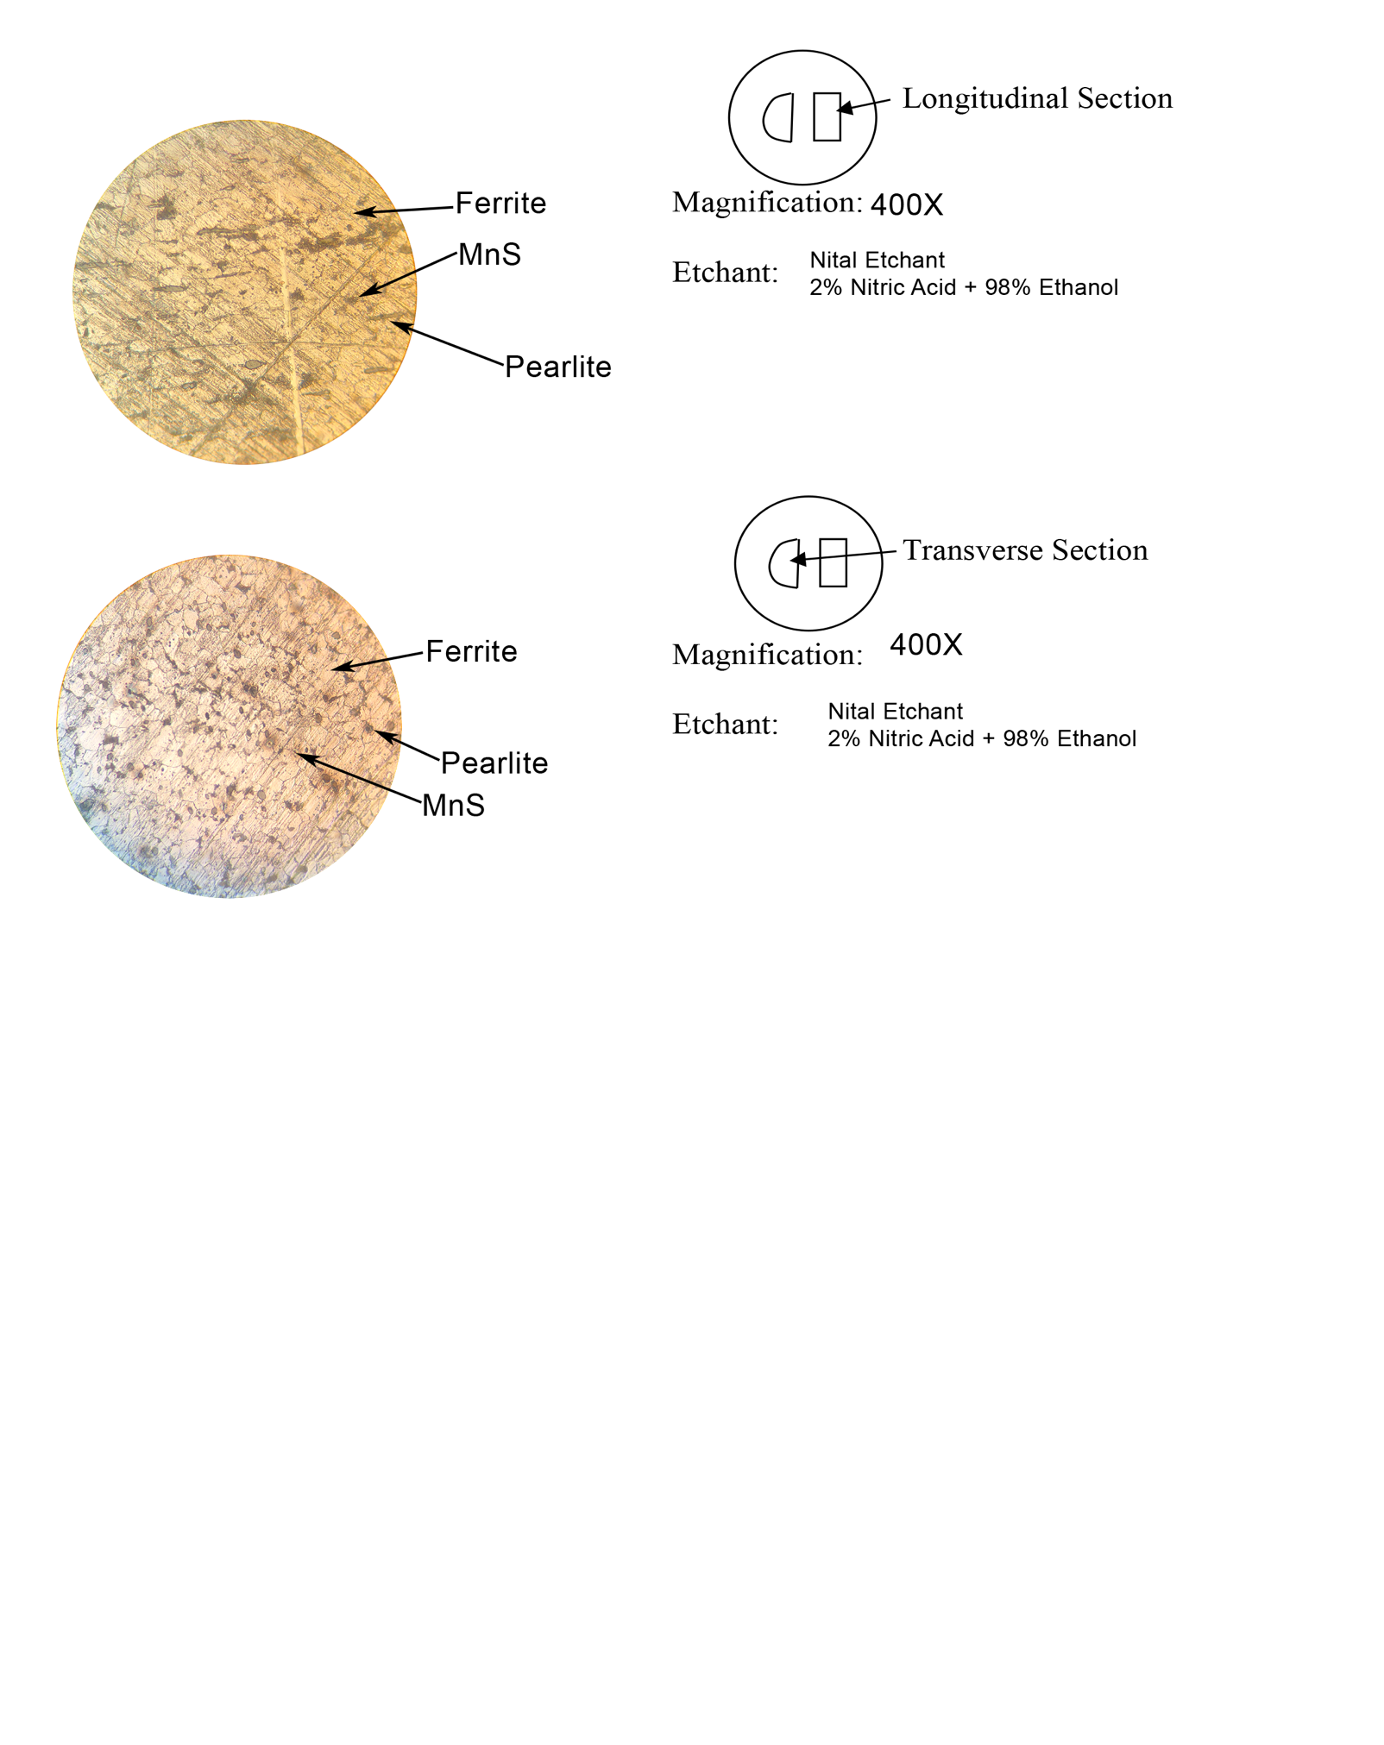
B. Examination of Wrought Iron Bar (Label all phases on each sketch)

Fig. 4

Fig. 5

Discussion of Wrought Iron Bar:
Within the transverse view, the microstructure appears equiaxed and lines within the grains are visible due to possible error in the grinding process such as scratches or not grinding the surface enough. This can cause the surface to appear as if there are evident straight lines in which the scratches were created and can indicate that the layer being seen is a light disturbed layer. The disturbed layer that may be present could cause the microstructure to appear as if there are more grains than there actually are due to how the microscope works by reflecting light. Assuming our errors in the grinding process, the surface may not have been as polished and mirror like as we would’ve liked due to time constraints. This could’ve added factors of error such as a minimal disturbed layer with scratches. If we have had a perfect grinding process, idealistically, our specimen would have displayed the grain structure nicely.
The process in metallography is extremely important in viewing the proper microstructure of a sample. In our case, as previously stated, errors and improper steps in the metallography could affect the sample drastically. The wrought iron however, having higher melting temperature than the carbon steel, would have helped more in preventing a greater disturbed layer to be formed in the grinding processes due to the heat of the belt sanders. This is helpful in preventing that buildup of unnecessary disturbed layer. Within both the transverse and longitudinal views, the grains appear similarly with slight differences due to the grinding and cutting process.
The longitudinal section shows grains being more equiaxed microstructure in the grains as it was the surface area opposing the cutting force. As mentioned, the grain structure is likely to have surface impurities due to the metallography process. Visually, the impurities are visible in the dark specs seen and is perhaps the most significant difference between the two sections. This is evidence of a disturbed layer and had the grinding process been perfect, minimal impurities would be seen within the microstructure view.
The metallography process is a significant factor in the results we are able to obtain, and due to this, is why the labour of this process has an expensive cost. We were able to learn and understand what went on within our specimen based on our microstructure and throughout the grinding process we were able to understand the reasons such procedures were so important. Our expected results would have displayed a smoother finished surface displaying little to no impurities within the face of the sample. Upon viewing the impurities however we can truly understand how significant factors can be in the effect of a metal structure and how impactful the experimental processes themselves can change a microstructure of a specimen. In our case, we could have spent more time grinding at each intermediate step to achieve a mirror finish. Even within these steps, error may still be common as the surface is always being worked slightly throughout the grinding. As the grind got finer and finer, less and less of the material was being removed, but since we possibly didn’t spend enough time on each of the steps, the impurities and the small disturbed layers that were created, were visible within the microscopic view after they were dissolved by the nitric acid etchant, thus why it was made visible.⁷
C. Metallography Questions

Explain why metallographic samples must be kept cool during cutting and grinding.

By keeping the sample cool during the cutting and grinding process, it allows the microstructure of the sample to remain uniform and consistent throughout the process. During cutting and grinding, if the sample were to be heated up significantly due to the friction, it could be significant enough to change the microstructure of the sample subject considerably creating a disturbed layer, and the results being seen wouldn’t reflect the original sample that was objectively desired to reach. The significant increase of temperature and forces exerted could cause the sample to be work hardened or even heat treated, which would affect the microstructure of the sample.

Explain the purpose of mounting samples in materials such as Bakelite.

Mounting allows the sample to be protected and retain a workable edge to view under the microscope. The mounting in bakelite allows for ease of workability within the sample and provides a safe and convenient way of handling the small sample. Within our lab this is evident especially during the preparation stage in which we were to sand and finish the surface before viewing under the microscope. The bakelite mount allowed for the preparation to be performed effectively, safely, and more easily. Since the sample was relatively small as well, it prevented the mishandling of such a sample.
https://www.struers.com/en/Knowledge/Mounting#

Why are there several intermediate grinding and polishing steps between the sectioning of the sample and final polishing?

The many intermediate steps taken within the lab procedure of grinding and polishing the sample are necessary in removing any surface flaws such as cracks, scratches and contaminants that may impede the microstructural viewing of the sample. Factors such as cold-working and overheating also are lessened during the grinding stage of the sample to unveil deeper layers of the sample to further demonstrate its proper microstructure. In order to achieve proper microstructural viewing, the disturbed layer must be removed during the grinding process. Each further step of grinding allows for different results. The first coarse grind performed allows for the disturbed surface to rapidly degrade however it creates its own small disturbed layer. The proceeding steps, with finer grinding, slowly removes the material revealing an unblemished, microstructural layer that is suitable for viewing under a microscope.

Sketch and explain how an etchant reveals the grain boundaries of a metal sample.

The nitric acid etchant works by revealing dissolving the grain boundaries of the microstructure in the sample which then reveals what would’ve been the grain boundaries making them visible under a microscope by creating small trenches from the dissolved material. This also assists in the microscopic viewing as the flat, polished surface reflects light back into the microscope making it visible to the eye, and in contrast, the dissolved grain boundaries appear darker due to the lack of surface reflecting light.
Sketch on next page →

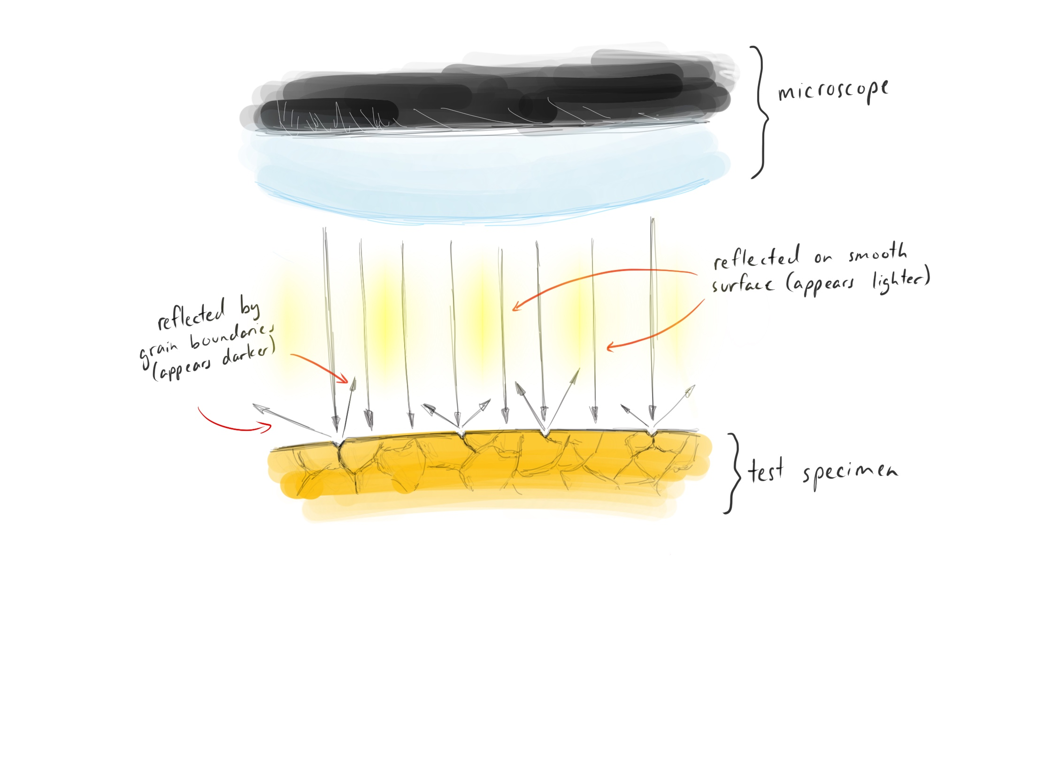
Fig. 6

References:

1. Callister,
William D., Jr., 1940- author.
Materials science and engineering : an introduction.—9th edition / William D. Callister, Jr.
Department Of Metallurgical Engineering, the University Of Utah, David G.
Rethwisch, Department of Chemical and Biochemical Engineering, the University of Iowa.

2. BCIT.
Lecture Slides, D2L

3. BCIT.
Lab Report Guidelines, D2L
  - Page 1
  - Page 2

4. CES EduPack 2019

5. Birmingham Fastener. “Rolled Thread vs. Cut Thread Bolts.” Birmingham Fastener, 3 Dec. 2018,
www.bhamfast.com/rolled-thread-vs-cut-thread-bolts/.

6. Reshift Media. “Difference Between Hot and Cold Rolled Steel: Metal Supermarkets.” Metal
Supermarkets - Steel, Aluminum, Stainless, Hot-Rolled, Cold-Rolled, Alloy, Carbon, Galvanized, Brass, Bronze, Copper, 17 Dec. 2019, www.metalsupermarkets.com/difference-between-hot-rolled-steel-and-cold-rolled-steel/.

7. About Mounting. (n.d.). Retrieved from https://www.struers.com/en/Knowledge/Mounting#

Supplementary Assignment

Task 1:

Within the article, “Microstructure and Failure Analysis of Flash Butt Welded HSLA 591CL Steel Joints in Wheel Rims”⁷, we can see how beneficial and integral the metallographic process is in order to examine the microstructure effectively. The microstructure of a material can convey significant information that can ensure the quality of the product is up to standards. As this article describes, its aim is to evaluate the microstructures of the wheel rims and analyze the failure behaviour of the HSLA steel to ensure quality.

HSLA steel has been determined by research, to create a coarse Widmanstatten structure and produce a small quantity of bainite which can drastically affect the mechanical properties of the welded steel. Because of this, further inspection of the microstructure is required in order to identify possible failures affecting the mechanical properties.

The process used in order to investigate the wheels microstructure which is very similar to that of the one we performed in our lab. The HSLA steel was cut from the wheel rim, and the cross sections were grinded and polished before being etched with a nital liquid to view the grain boundaries. It was then taken to be viewed under an optical microscope to examine the microstructure of the heat affected zone within the welded joints (Figure 2).

The microstructure of the steel prior to welding showed equiaxed ferrite grains. Due to the addition of heat from the welding, as well as the cooling process, Widmanstatten ferrite was formed in feather like grains, parallel to the ferrite. This resulted in a weakness in plasticity and impact toughness.

The use of proper metallographic techniques allowed them to examine the microstructures between the metals and the weld to determine the type of failure that occurred and at which points of the rim. This case is a good example on how examining the microstructure of a material can be helpful when determining the failure of a product. Because grains are unique due to material processing, it can be used to identify properties and characteristics.

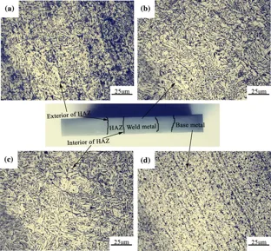
Figure 2. Microstructures of HAZ of Welded HSLA Steel⁸
https://link.springer.com/article/10.1007/s11837-016-2173-x (photo references)

Task 2

1.
Graph 1 Strength (x-axis) and Fracture Toughness (y-axis) of Mg and its alloys
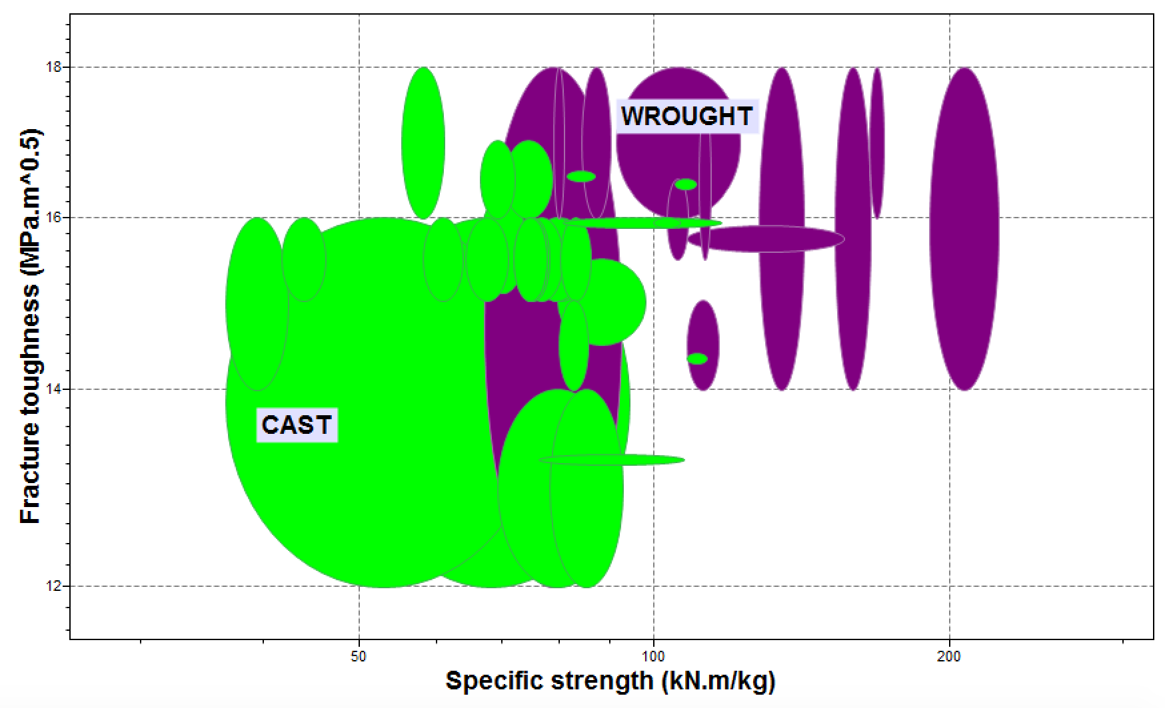

From the graph, it tells that the wrought alloy has greater tensile strength and Fracture toughness than cast alloys in general. The reason of these two types of alloys metals have various mechanical properties can be explained from the point of view its alloying elements and manufacturing process;

Mg has the characteristic of lightweight and low melting point, and also relatively soft compared to other metals. Therefore, it's usually recommended for casting and machining. Commonly alloys are Al-Mn, Al-Zn, and Al-Si, which provides elevated strength and maintain its ductility and castibility, and enhances the further casting process and when it uses in application.

2.

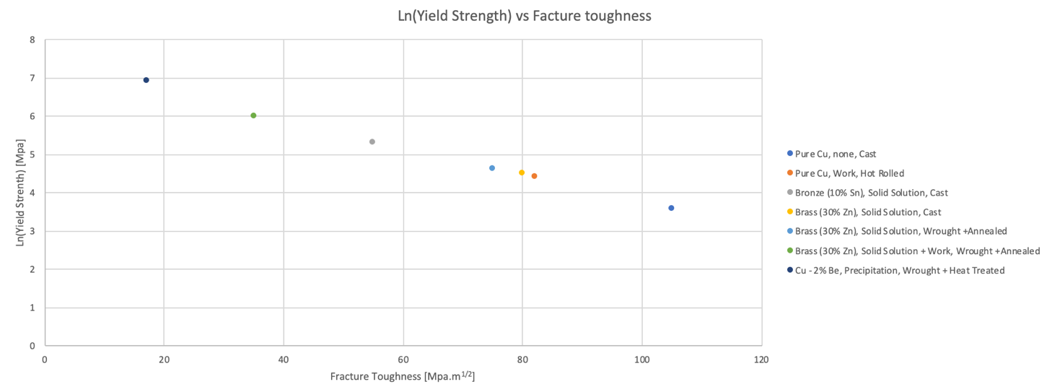

2.

- Wrought alloys tend to have a higher fracture toughness than cast alloys at a comparable strength.
- Strengthening Mechanisms Effectiveness Ranking
Precipitation, Solid Solution + Work, Solid Solution, Work, None

